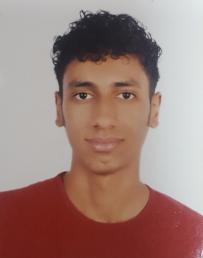

**YASSER ABDULNABI AHMED DARWESH**

Yasser.x7@gmail.com

Mobile 35366036

**PERSONAL DETAILS**

**Nationality**: Bahraini

**Date of Birth**: AUGUST, 23 1998

**OBJECTIVE** To work in a challenging and stimulating environment with opportunity to use my current experience and to enrich my knowledge and enhance my experience. To contribute towards the achievement of organizational objective by applying my professional skills.

**EDUCATION Jidhafs Secondary Industrial School for boys**

Automotive Major , 2015-2018

**EXPERIENCE Y K Almoayyed & sons –** Salmabad 15/10/2017 to 9/11/ 2017AutomotiveTraining program with grade A

**ACTIVITES** Hard worker, work well under pursuer, deal well with people

**& SKILLS**

**REFERENCES** Available Upon Request